
Center for Renaissance Studies

Mellon Summer Institute in Spanish Paleography

June 12, 2017 – June 30, 2017

Directed by Carla Rahn Phillips, Emerita, University of Minnesota
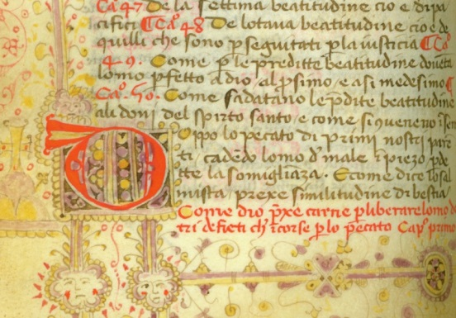
The institute will provide participants with practical training in reading and transcribing documents written in Spain and Spanish America from the late fifteenth to the early eighteenth centuries. Although the course sessions will be taught primarily in English, all of the documents will be in Spanish. Participants must indicate in their applications that they have a working knowledge of the Spanish language. They should also indicate why this institute would be of use to them in their research, teaching, or professional lives. Participants will have time available outside of class for required homework and for their own research projects.

Schedule: The institute will meet in the mornings Monday through Friday, plus a couple of hours on the Monday afternoons, for three weeks.
Eligibility: Each institute will enroll 15 participants. First consideration will be given to advanced graduate students and junior faculty at U.S. and Canadian colleges and universities, but applications will also be accepted from associate and full professors at U.S. and Canadian colleges and universities, from professional staff of U.S. and Canadian libraries and museums, and from qualified independent scholars. Advanced language skills are required. Applicants selected for admission will receive a stipend to help defray expenses while attending the institute.
Award: All successful applicants will receive a stipend of $970; non-local participants will receive an additional stipend of $2,500 to help cover travel and housing expenses. There are no fees associated with the institute.
Prerequisite: This graduate-level course is taught in English, but participants will do extensive reading in early forms of Spanish; advanced language skills are required.
Funded by a major grant from the Andrew W. Mellon Foundation.

Application deadline is March 1, 2017.
www.newberry.org/renaissance

